Key and Mouse Listener Notes

KeyListener
The programmer will now write GUI interface that will respond to keystrokes and mouse clicks. The programmer should create a graphics runner, frame, and panel. The KeyListener are able to respond to keyboard events. To do this, the user needs to import java.awt.event.KeyListener; There are three methods that are useful for the KeyListener: keyPressed(KeyEvent e), keyTyped(KeyEvent e), and keyReleased(KeyEvent e).
keyPressed will react when you depress a key. keyReleased will react when the key goes up. These two methods can be used for continuing action.

keyTyped(KeyEvent e)
The keyTyped event is what the programmer will focused on. The KeyEvent is found in java.awt.event.KeyEvent; It gives you the following methods: getKeyChar() that returns the char value of the key and getKeyCode() which returns a numberic value of the key pressed. The KeyEvents API will give you a list of key codes that the programmer can identify.
The programmer will create a JPanel that will use the KeyListener. The program will wait for a number to be typed and once a number is typed, then an image will appear.
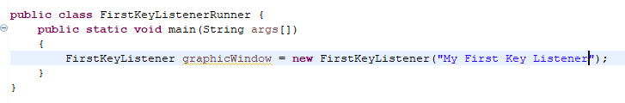
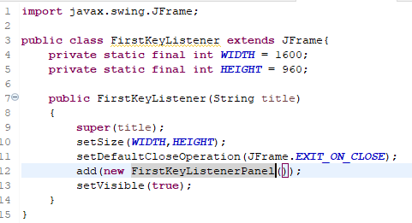
The programmer would create the FirstKeyListenerPanel.
The programmer would first write the following:
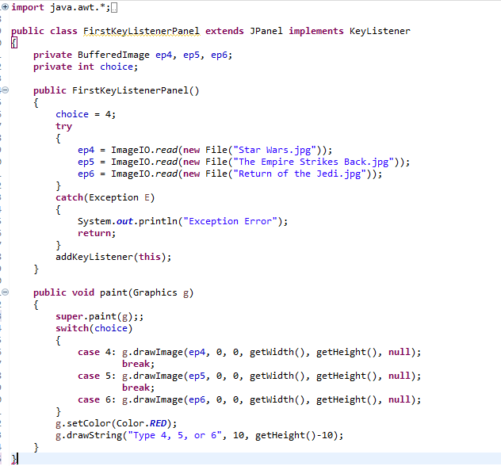
The programmer created a private int choice because it will indicate what the paint needs to do. In the constructor, the programmer sets choice to 4 as a default. The paint method would then use a conditional statement to choose which image to print. The last thing the programmer would do is to create a String to indicate what the user should do. When this program runs, it will only show the first image, but it is primed to be used when an Event occurs.
The choice data type is actually representing a game state. Eventually this data type will be a game state object that can be called inside of paint to decide what needs to be done.
The programmer would then add the KeyListener and KeyEvent libraries as well as implement the KeyListener interface:
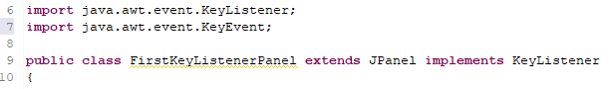
The programmer will then define all three KeyListener methods in the FirstKeyListenerPanel, although the only one that will do anything will be the keyTyped method. The getKeyChar() has to be converted the integer value of the character in order to store the correct number. repaint is a method that will automatically call paint. This method will make the picture update.
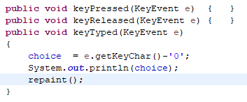
The programmer would then go into the constructor and let the program know to listen for a keystroke by typing the following:
addKeyListener(this);
The programmer would then request focus by overriding a method in JPanel called addNotify by adding the following method to the FirstKeyListenerPanel
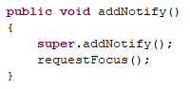
The program will run and the images will change when a 4, 5, or 6 is typed and it will do nothing when anything else is printed.

MouseListener
MouseListener follows the same pattern as KeyListender but there are some changes. The import statements are java.awt.event.MouseListener and java.awt.event.MouseEvent. The methods are now mousePressed(MouseEvent e), mouseClicked(MouseEvent e), mouseReleased(MouseEvent e) as before. But there are two more methods to be concerned with mouseEntered(MouseEvent e) when the mouse enters an area of the frame/panel and mouseExited(MouseEvent e) when the mouse leaves the area of the frame/panel.
The MouseEvent has three methods that are useful: getX(), getY(), getButton() which returns what mouse button is clicked. MouseEvent API can descripe all the buttons, but for us, BUTTON1 is the left button of the mouse.
The programmer is going to adjust the previous program and provide three buttons to choose the picture. The programmer will revise the FirstKeyListener class so that it add a FirstMouseListenerPanel.
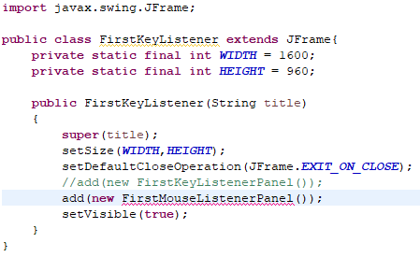
The FirstMouseListenerPanel will import the necessary libraries and implement MouseListener
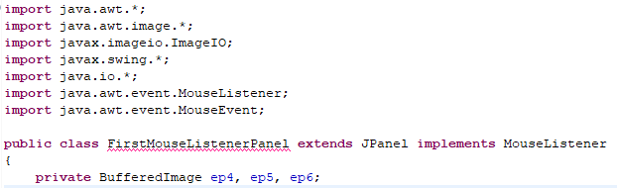
Instead of having an int choice, the programmer chooses to have a BufferedImage hold the choice and sets up the constructor accordingly. The choice is applied after the images are read. addMouseListener is added to let the panel know to listen to mouse.
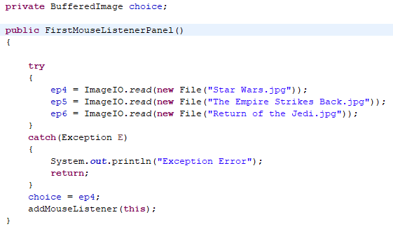
The programmer would write a print method that will print out the current image and 3 boxes of different color that the mouse could click on.
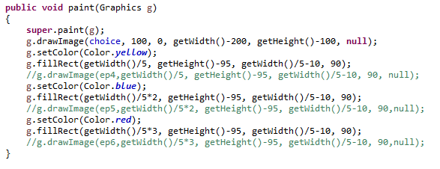
The programmer would then write the Mouse methods. The only mouse method they will be concerned with is mouseClicked. They would receive an x and y coordinate. The programmer needs to check and see if that location is inside one of the colored boxes. If it is, then the program will change to a different image.
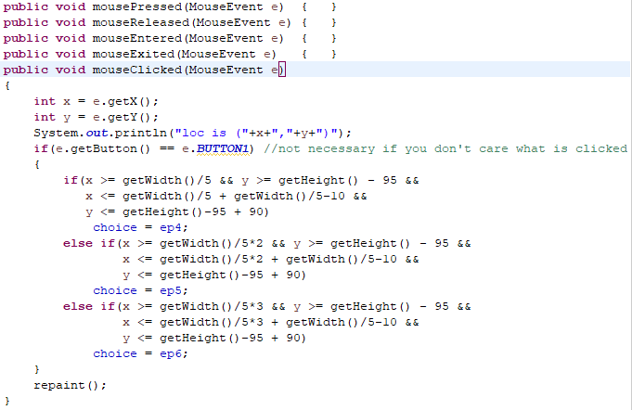
The resulting window will look like this
